# 2X ARCH SUPPORT FOOT CUSHİON PAD

# 

Ürün Linki**:** [**https://tr.aliexpress.com/item/1005002797089413.html?gatewayAdapt=glo2tur4itemAdapt**](https://tr.aliexpress.com/item/1005002797089413.html?gatewayAdapt=glo2tur4itemAdapt)

## The Arch Supports, help to specifically alleviate pain associated with Plantar Fasciitis, Heel Spurs, Metatarsalgia, and Fallen Arches. The support of the Patented shock-absorbing gel-foam core coupled with a medical-grade compression band helps to relieve tension on irritated ligaments eliminating the cause of foot pain.

|  |  |  |
| --- | --- | --- |
| **Ürün maliyeti** | **Satış fiyatı** | **Satış Başına Kâr** |
| **$5.04** | **$17.99** | **$12.95** |

**I. Ürün Talebi ve Doygunluk**

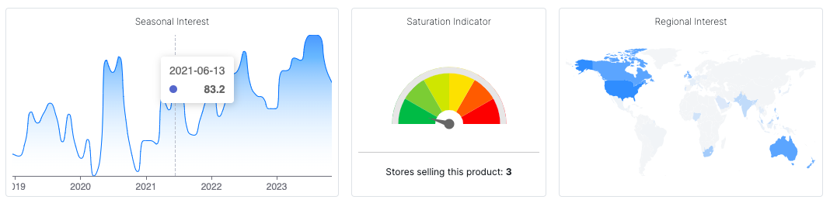

**II. Sosyal Medyada Hedefleme**

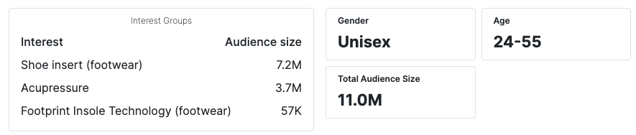

## **III. Rekabet ve Temel Metrikler**

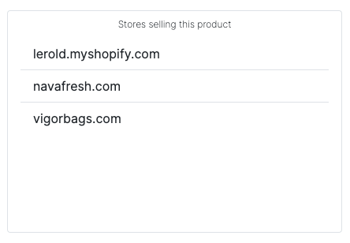

|  |  |  |  |  |
| --- | --- | --- | --- | --- |
| **Aylık gelir** | **Aylık Satış** | **ROI** | **AliExpress Siparişi** | **Amazon Fiyatı** |
| **$52.326** | **3.293** | **257%** | **+500** | **$14.99** |

## **IV. Uygun Instagram Fenomenleri**

